Interface ID: FTP-54
Created by: Mark Lund
Created Date: 9-28-2005

Description of Design Concept:
While processing the records from the MSMQ queues, the vsdVFSImmediateUpdate and vsdDPImmediateUpdate may encounter the following types or errors:
– 01 recoverable errors
– 02 non-recoverable errors
– 03 NMVTIS Brand Update failure recoverable error
When a 02 non-recoverable error is encountered it is immediately written to an exception table for manual resolution. When a 01 or 03 recoverable error is encountered the service will place it back in the queue for re-processing. However if the record continues to receive 01 or 03 error conditions and the number of retries exceeds the service’s “retry threshold” the record is not written back to the queue, it is written to the exception table.

When records are written to the exception table an email notification is sent to support staff so that the source of the error can be determined and resolved. Once the source of the error has been determined and resolved, the records written to the exception table need to be placed back into the queue to be re-processed.

The purpose of this application is to place the records back into the queue and remove them from the exception table. It is a batch process that will be executed on an ad-hoc basis.

Performance:
N/A. This job is a recover batch job that is triggered manually.

Decomposition/Flow Diagram:
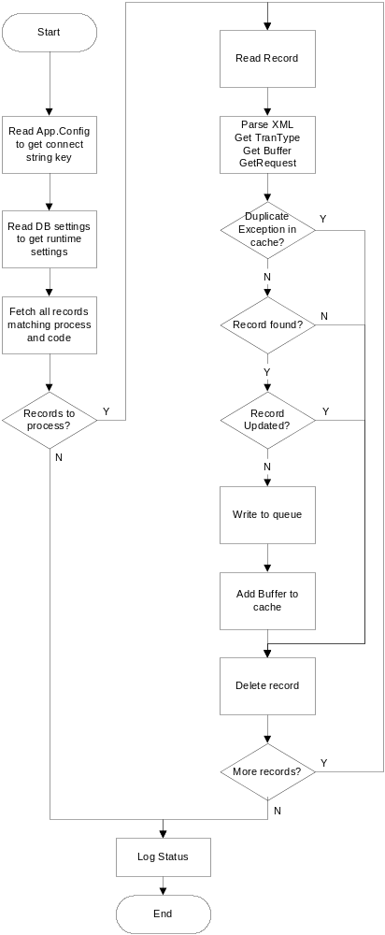

Functional Specifications:

Upon startup, the job will read its utAppConfig settings to obtain its start up parameters. This job can handle exceptions for either the vsdVFSImmediateUpdate service or the vsdDPImmediateUpdate service, or both. It also can handle specific response types (01, 02, or 03).

After obtaining its operating parameters, the job will fetch all records in the buException table that match the process (VFS or DP) and response type values (01, 02, or 03).

The same queue record could be written to the buException table multiple times so the job will maintain a cache* so that one copy of the queue message is returned to the queue.

If the record has not already been returned to the queue, the record still exists in the Field System table, and it has not been updated, the message is returned to the queue and the record is added to the cache so subsequent duplicates can be detected. The record is then deleted from the buException table and the steps are repeated until all records have been processed.

* There is a nearly insignificant exposure to using an in-memory cache for tracking the messages returned to the queue. If there are duplicates (which should be rare) AND if the batch job aborts, duplicate messages could get returned to the queue.

For example, suppose there are three records in the exception table representing two transactions - A1, B1, and A2. A1 and A2 are duplicates for the same transaction. We put A1 in the queue, add it to the in-memory cache, and delete it from the exception table. While processing B1, the job aborts and the memory cache is lost. The next time the job runs, A2 is found but A1 is no longer in the cache so it gets added to the queue.

However, there really is very little impact because the vsdVFSImmediateUpdate should handle this condition quasi-gracefully by detecting that transaction "A" was updated during A1. So when it gets to A2 and sees that transaction "A" is already complete, it will send an e-mail and continue.

